**VISION AND MISSION OF THE INSTITUTE**

❖ **VISION:**

Achieve excellence in quality technical education by imparting knowledge, skills and abilities to build a better technocrat.

* **MISSION:**

**M1:** Empower the students by inculcating various technical and soft skills. **M2:**Upgrade teaching-learning process and industry-institute interaction continuously.

**VISION AND MISSION OF THE COMPUTER DEPARTMENT**

* **VISION:**

“Enhance skills by providing value based technical education for fulfilling global needs in the field ofcomputer engineering.”

* **MISSION:**

**M1:** To provide quality education in computer engineering by improving psychomotor skills.

**M2:** To develop positive attitude, communication skills, team spirit and entrepreneurship.

**M3:** To develop awareness about societal and ethical responsibility for Professionalism.

**INDIA SHRI SHIVAJI MEMERIAL SOCIETY’S POLYTECHNIC, PUNE -1**

**PROGRAM OUTCOMES (POs)**

**PO1 Basic knowledge:** An ability to apply knowledge of basic mathematics, science and engineering to solve the engineering problems.

**PO2 Discipline knowledge:** An ability to apply discipline - specific knowledge to solve core and/or applied engineering problems.

**PO3 Experiments and practice:** An ability to plan and perform experiments and practices and to use the results to solve engineering problems.

**PO4 Engineering Tools:** Apply appropriate technologies and tools with an understanding of the limitations.

**PO5 The engineer and society:** Demonstrate knowledge to assess societal, health, safety, legal and cultural issues and the consequent responsibilities relevant to engineering practice.

**PO6 Environment and sustainability:** Understand the impact of the engineering solutions in societal and environmental contexts, and demonstrate the knowledge and need for sustainable development.

**PO7 Ethics:** Apply ethical principles and commit to professional ethics and responsibilities and norms of the engineering practice.

**PO8 Individual and team work:** Function effectively as an individual, and as a member or leader in diverse/multidisciplinary teams.

**PO9 Communication:** An ability to communicate effectively.

**PO10 Life-long learning:** Recognize the need for, and have the preparation and ability to engage in Independent and life-long learning in the context of technological changes.

**PROGRAM SPECIFIC OUTCOMES (PSO)**

The Diploma in Computer Engineering will prepare students to attain:

* + **PSO 1:** Apply computing knowledge with standard practices to develop software.
  + **PSO 2:**Maintain Computer Hardware and Software System

**A PROJECT REPORT**

**ON**

**Development of an Android Application for Maharashtra Tourism**

IN THE PARTIAL FULFILLMENT OF THE REQUIREMENTSFOR THE AWARD

OF

**DIPLOMA IN COMPUTER ENGINEERING**

**(2020-2021) BY**

|  |  |  |  |
| --- | --- | --- | --- |
| **ROLL NO** | **Name Student** | **Branch** | **Batch** |
| 2404 | Nirmal Gopal Avhad | TYCO First Shift | CO-6I |
| 2411 | Tanmay Dilip Birari | TYCO First Shift | CO-6I |
| 2437 | Sidra Farooque Khan | TYCO First Shift | CO-6I |
| 2452 | Rahul Nagarajan | TYCO First Shift | CO-6I |

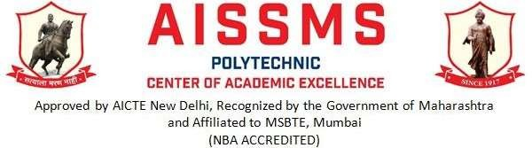

**DEPARTMENT OF COMPUTER ENGINEERING AISSMS’S POLYTECHNIC**

**KENNEDYROAD PUNE 411001**



**DEPARTMENT OF COMPUTER ENGINEERING**

**C E R T I F I C A T E**

**This is to certify that the project report entitles**

**“Development of an Android Application for Maharashtra Tourism”**

**Submitted by**

|  |  |
| --- | --- |
| **ROLL NO.** | **NAME OF STUDENTS** |
| **2404** | **Nirmal Gopal Avhad** |
| **2411** | **Tanmay Dilip Birari** |
| **2437** | **Sidra Farooque Khan** |
| **2452** | **Rahul Nagarajan** |

Is a bonafide work carried out by them under the supervision of Mrs. **V. C. Sanap and** it isapproved for the partial fulfilment of the requirement of MSBTE for the award of the diploma in Computer Engineering.

**Mrs. V. C. Sanap Prof. V. N. Kukre.**

Guide Head

Department of Computer Engineering Department of Computer Engineering

**Prof. S. K. Giram**

Principal,

AISSMS’s Polytechnic, Pune – 01 External ExaminerPlace: Pune

Date:

# Acknowledgement

With an immense pleasure and satisfaction, I am presenting this Project report as part of the curriculum of Diploma Computer Engineering. I wish to express my sincere gratitude towards all those who have extended their support right from the stage this idea was conceived.

I am profoundly grateful to **Mrs. V. C. Sanap.**, Project Guide, for his expert guidance andcontinuous encouragement throughout to see that project work right its target since its commencement to its completion.

I am thankful to **Prof. A.N. Gedam** , Project Coordinator, for conducting and supporting such research activities.

I am also grateful to **Prof. V. N. Kukre**, HOD, Department of Computer Engineering, for his support and encouragement.

Finally, I am also grateful to Honorable **Prof. S. K. Giram**, Principal, AISSMS POLYTECHNIC, Pune, for his support and guidance that have helped me to expand my horizons of thought and expression.

Signature

#### Nirmal Gopal Avhad Tanmay Dilip Birari Sidra Farooque Khan Rahul Nagarajan

**ABSTRACT**

Developing an Application for Tourism guide gives the users the immense feeling to explore around their area. There is no doubt that travel is one of the top three sectors disrupted by technology. Smart tourism provides various tour and tourism services based on Internet of Things (IoT), communication system, bigdata and Artificial Intelligence (AI) of the key technologies of the 4th industrial revolution. The tourism bigdata platform provides tourists information on tourism destinations and festivals by data analysis. Travel apps are taking the center stage in the mobile app development, as more and more people are using them. The travel industry is growing drastically as never before and since there are always new apps coming out one of the most thought over questions is what are the essentials ingredients of the best travel apps? There are tons of different travel apps out there today, with all kind of interesting features. The main problem of frequent travelers who are traveling whole around the world needs this kind of app, but due to limited storage and switching to different apps it become tedious for the traveler and spoils the mood.This paper presents a new approach for smart search.

# INDEX

|  |  |  |  |  |
| --- | --- | --- | --- | --- |
| **Sr.**  **No.** | **Title** | | | **Page No.** |
| 1 | Introduction | Idea of the Project | | 9 - 16 |
| Motivation of the Project | |
| Overview | |
| Brief Description | |
| 2 | Analysis | Project Plan | | 17 - 25 |
| Software Requirement Specification | |
| Problem Definition and Scope | |
| 3 | Detail of Design, Working and Processes | | | 26 – 37 |
| 4 | Results and Application | | | 38 – 41 |
| 5 | Testing | | Software Testing Types | 42 – 46 |
| Integration Testing |
| Test Cases |
| 6 | Conclusion | | | 48 |
| 7 | Future Scope | | | 50 |
| 8 | Publication | | | 51 |
| 9 | References and Bibliography | | | 61 |

**1 .0 I NTRODUCTION**

## PHASE 1

**INTRODUCTION**

### IDEA OF THE PROJECT:

The main goal of this project is to minimize searching work and human efforts. The aim of the project is to develop an android app that helps travelers on his/her journey. The purpose of our project is to provide the basic idea on some common conversation in the different places that the travelers need to go after coming to that place. The main aim of this research is to develop a mobile travel guide application with added functions to an existing application. Especially in this application, the interaction between users is the new function compared to traditional travel. The main objectives of the project are to understand the basic of android development involved in app development, to understand the trends and working of Travel app currently used, to understand how to implement the different algorithm on the real time problem, to understand the flow in software development and documentation associated with it.

### MOTIVATION OF THE PROJECT:

Technology is constantly advancing and changing, and the travel and tourism industry market will progress along with it. There has been a rise in the use of mobile devices in certain fields like the tourism sector in recent years, consequent to the fact that mobile phones are presently the existing platform for ubiquitous computing due to their accessibility and handy nature. The recent increase in mobility of tourists in the world, has led to great interest in tourism flows. In recent times, most researchers emphasize on balancing the needs and behavior of tourists and also the general surrounding.

Several people around India and state of Maharashtra itself have not gone through the places which are unseen and unexplored. Through the Application by providing the Appropriate and extea features will do the needful for the users and surveying techniques in the study of tourism geography has improved, since the GIS and other important visualization techniques have relevant functions in the tourism sector.

#### Some Statistics on Tourism Industry of Maharashtra,

* + - According to research, by 2029, India’s tourism sector is expected to grow 6.7% to reach Rs.35 trillion (US$ 488 billion), and accounting for 9.2% of the total economy.
    - Selection of Tourist Destinations and Locations: Important destinations of tourist attraction and their location in the district were selected in consultation with the State Tourism Department.
    - Maharashtra data was **reported at 149,294,703.000 Person in 2019**. This records an increase from the previous number of 119,191,539.000 Person for 2018.

#### If we talk about the benefits and advantages of Tourism Android Application then then there wouldhundreds of them as,

* + - **Get Real View Pictures and Videos of Destination**
    - **Provides 24/7 Customer Support:** A digital talking assistant does not require any off days orsick leaves that interrupt customer care and experiences.
    - **Eradicates Language Barriers:** While travelling around the state or even while interacting with contentonline, most people have to deal with language barriers. So what’s the solution? Including

personal assistant technology integrated with automatic translation to help ease the language barrier.

* + - **Saves Time by Automating Repetitive Tasks:** Automating repeated tasks to a voice- activatedpersonal assistant frees up the human time and resources.
    - **Aids Hand-free Operation:** Voice talking gives consumers hands-free access to many functionsbecause you only need the voice to activate them.

### OVERVIEW:

Maharashtra, a state with natural beauty and historical places, is visited by many foreigners from different countries, people from various states in India as well as local people. The purpose of foreigners‟ visit to this state is diverse. The most dominant purpose is tourism.

The number of people interested in tourism is increasing day by day. They travel to Maharashtra for different purposes such as visiting, religious, job, business and so on. Statistics indicates “Tourism is the strongest and largest industry in the global economy world, generating an estimated 11% of the global gross domestic product (GDP) and employing 200 million people and serving 700 million tourists worldwide-a figure which is expected to double by the year 2020

In this Maharashtra Tourism Guide Project system, the map of the city is provided to the people in their phone which they get them via installing this application into their android phone. The map will help the travellers to find their desired location. The side bit also consists of the details other than location such as how will they reach their and how will they enjoy their and so on. This Maharashtra Tourist Guide Project applications is truly designed for the people who loves to travel and many a lot of times they are the alone one’s who travel. This application works on android platform.

### BREIF DESCRIPTION:

What is a Tourism Application?

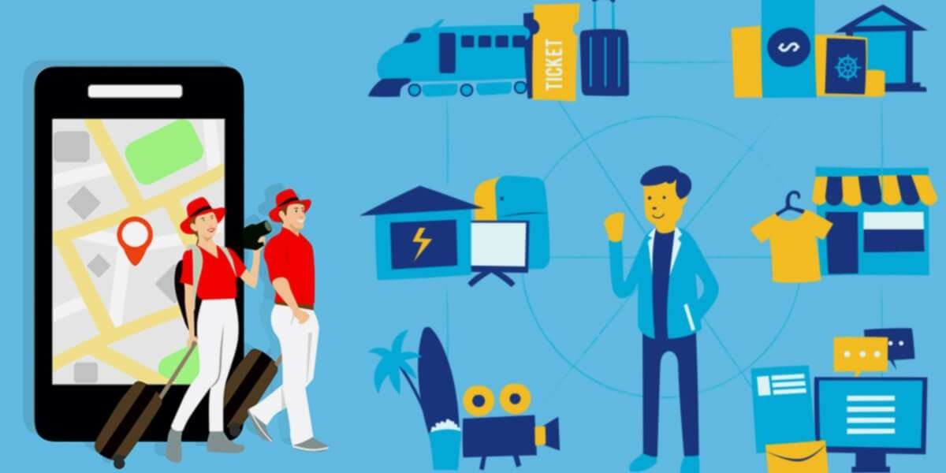

Tourism Mobile apps help users for planning travel, accommodation bookings, ticket bookings, cab booking, route mapping, and more. Navigation – GPS services, route planning, and maps. Social – Travel updates, reviews, picture galleries, free communication, etc. Mobile Marketing – Contests, discounts, and offer alerts.

Through the survey conducted by us, we are trying to cover all ideas of better guidelines of tourism.

In accordance with about 50% of existing tourism recommender systems is designed for mobile devices. As has been the case with other information and communication technologies, tourism has manifested as one of the most well-suited sectors to mobile technology and mobile applications. The main purpose of this project is when users are on the move, it is able to provide rich and concise information and make them access the service at anytime and anywhere.

* The Maharashtra Tourism Guide app is based on request and response, so there is no continuous acquisition of the bandwidth and overcomes the problems of current

location based travel system. This application is also helpful for the user who is

visiting a new city and helps them to obtain the tourists attraction places, religious places, dams, forts, hotels with wide range of information.

Functionality of Maharashtra Tourism Guide app:

* + Divisions vise distribution
  + District vise distribution
  + Each district contains: Forts, Temples, Places, Week Masti

The following is the overview of the user interface of the application. The entire execution flow of Maharashtra Tourism Guide App is described as below.

1. **Login Screen:** The login screen checks for the authentication of the user to prevent the application from unauthorized use. The following fig.1 shows the login screen of the application. Here the user should submit their email id and password for verification in order to be allowed to use the Maharashtra Tourism Guide App.
2. **Maharashtra’s Division based distribution:** When the user login into the app, a interface will be displayed. It will consist of division vise distribution of Maharashtra State. It consists of 4 divisions i.e., Pune Division, Aurangabad Division, Konkan Division and Nagpur Division.
3. **District based distribution:** After selecting particular division, it will display districts of the division. Fig.3 shows the Pune Divisions districts. It consists of Pune, Satara, Kolhapur and Solapur districts.
4. **Districts:** Pune Division districts contains Pune, Satara, Kolhapur and Solapur. Each district holds information about tourist’s attraction places, religious places, dams, forts, hotels. If user selects Pune district Fig.4 shows the attributes contains in it. Here user can choose where he wants to go.
5. **Nearby Famous Restaurant:** This app displays a list of famous nearby restaurants with pictures and detailed information such as address, opening and closing time of restaurants and famous dishes to try.

# 2.0 ANALYSIS

## PHASE 2

**ANALYSIS**

### PROJECT PLAN:

* + 1. **PORJECT ESTIMATE:**

The estimation of project can be carried out depending upon the feasibility study of all the service (i.e. modules) which is included in our project. The numbers of lines of code, Function points are used for calculations of estimate. Since with the feasibility study for our project, it can be designed and developed within 5 - 6 months. The different stages like communication, planning, modeling, construction and deployment of waterfall model are used at every stage.

#### Reconciled Estimates

* + - * Requirement collection and analysis – 2 months.
      * Feasibility study - 2 month.
      * Design - 2 month.
      * Coding and testing - 3 months.
      * Deployment - 1 month.

### COST ESTIMATE:

Cost of a project is estimated using current estimation models such as Line of Code, Number of classes which allows us to estimate cost as a function of size. Thus, it also allows us to estimate and analysis the feasibility of the system in given time frame. As this project is developed completely using Java and XML Language, the expenditure during development are only the efforts made by the developer for the successful completion of the project.

### TIME ESTIMATES:

Since with the feasibility study for our project, it can be designed and developed within 5

- 6 months. The different stages like communication, planning, modeling, construction and deployment of waterfall model are used at every stage.

|  |  |  |
| --- | --- | --- |
| SR.NO. | DURATION | TASKS |
| **1.** | 17-August-2020 To 30-August-2020 | Selection of domain |
| **2.** | 1-September -2020 To 4-September-2020 | Topic selection |
| **3.** | 6-September -2020 To 10-September-2020 | Base paper selection. |
| **4.** | 19-September -2020 To 4-October-2020 | Existing System. |
| **5.** | 21-November-2020 To 12-December-2020 | Requirement collection from Industry |
| **6.** | 21-January-2021 To 25-January-2021 | Project proposal plan. |
| **7.** | 28-January -2021 To 29 -January-2021 | Presentation on project Plan. |
| **8.** | 26 – March-2021 To 15- April- 2021 | Module design. |
| **9** | 20-April-2021 To 30-April- 2021 | GUI |
| **10** | 1-May-2021 To 7-May-2021 | Implementation. |
| **11** | 11-May-2021 To 15-May-2021 | Testing. |
| **12** | 18-May-2021 To 22-May-2021 | Installation of application |
| **13** | Last week of May | Final Project presentation |

### SCHEDULE WORK:

#### Scheduling

Design is multi-step process that focuses on data structure, software architecture, procedural details, (algorithms etc.) and interface between modules.

|  |  |  |  |
| --- | --- | --- | --- |
| **Sr. No.** | **Task** | **Start Date** | **End Date** |
| 1 | Requirement Gathering | 21st NOV 2020 | 12TH DEC 2020 |
| 2 | Planning | 21ST JAN 2021 | 29TH JAN 2021 |
| 3 | System Designing | 26TH MAR 2021 | 30TH APR 2021 |
| 4 | Implementation | 1ST MAY 2021 | 7TH MAY 2021 |
| 5 | Software Testing | 11TH MAY 2021 | 15TH MAY 2021 |
| 6 | Documentation | 20TH MAY 2021 | 30TH MAY 2021 |

#### Table: 2 Scheduling Project

**Gantt chart**

|  |  |  |  |  |  |  |  |  |  |
| --- | --- | --- | --- | --- | --- | --- | --- | --- | --- |
| Task | Sept 17 | Oct 03 | Nov 22 | Dec 10 | Jan 25 | Feb 8 | Mar 14 | APRIL 16 | MAY 16 |
| Overview Project |  |  |  |  |  |  |  |  |  |
| Complete data of  project |  |  |  |  |  |  |  |  |  |
| Requirement gathering |  |  |  |  |  |  |  |  |  |
| High Level Design |  |  |  |  |  |  |  |  |  |
| Project Design |  |  |  |  |  |  |  |  |  |
| Coding Phase |  |  |  |  |  |  |  |  |  |
| Testing Phase |  |  |  |  |  |  |  |  |  |
| Project  Documentati on |  |  |  |  |  |  |  |  |  |

* + 1. **SOFTWARE REQUIREMENT SPECIFICATION:**

When a user wants to perform a task on his/her Android Mobile then he/she have to do or give command to the machine by hands using Android Mobiles. If you want to open Tourism Application the APK File will get downloaded in your Mobile and you can surf and go through the places around Maharashtra. And it contains the various features like Google Maps connecting from your location to the destination and you too can explore virtually by the video links provided.

This Tourism Android Application made by our group consists of many useful Java and XML modules such as module for data sharing, module for watching videos to explore virtually, modules for fetchinginformation from internet, modules that opens System Application and many more. Thus, by all means the system is secure as well as user friendly for anyone.

### PURPOSE AND SCOPE OF DOCUMENT:

The purpose of this documentation part in SQA is to describe each of the work products produced as part of the software processes.

**Overview of Responsibilities of Developer**

The team comprises of 4 members for development of the project. We all have different sets of knowledge; experience regarding the material used for the projects i.e. Knowledge of python programming language, Knowledge of testing and etc.

Member 1 - Documentation and most of the non-technical work. Member 2 **–** Non-technical planning and coding.

Member 3 – Technical planning and coding, Documentation. Member 4 - Technical planning and coding, Documentation.

### PROBLEM DEFINETION AND SCOPE:

* + 1. **PROBLEM STATEMENT:**

The main objective is to develop a android application that includes various information of places around Maharashtra and interact with the places virtually as well as decrease the human efforts on searching false information on internet.

#### Goals and Objectives

* + - * To reduce human efforts.
      * To make application more efficient.
      * Completing explore of places using GPS.
      * To provide an ease while interacting with the application.

#### Statement of Scope

* + - * The application will ask the password and will authenticate it.
      * It will check if the entered password matches with the original password.
      * If user enters a wrong password, then the gives a second chance.
      * Again, if user enters a wrong password then the program will terminate itself.
      * If the match found, then application will allow user to use it.
      * Then application will ask the user how it can help him.
      * According to user’s command, application will perform action and will give the results.

### SOFTWARE CONTEXT:

* + - * Android Studio Version 4.2.2.

### METHODOLOGIES OF PROBLEM SOLVING AND EFFIENCY ISSUES:

This app is developed to search a particular city's tourist attractions like forts, dams, religious places, restaurants, and hotels and avoid time consuming over different mobile applications.

So, not only this problem, many problems like can be solved very efficiently using Virtual Explore. This considers the performance parameters for each approach and considers the efficiency issues.

### OUTCOME:

* + - * High Security.
      * User Privacy.
      * Less human efforts
      * More Efficient.

### APPLICATIONS:

This system will help in increasing the efficiency and robustness of the Computer or Laptop System. It will decrease the time required to complete a particular task. It will provide very easy and entertaining way while completing or performing any task. It will provide flexibility to the user.

### HARDWARE RESOURCES REQUIRED:

#### The minimum hardware configuration required is,

* + - * Processor - Intel (any version)/ Android (any version).
      * RAM - 4 GB or above.
      * Hard Disk – 5 GB or above for Laptop/ 100 MB or above for Android Mobile.
      * Machine – Laptop/ Computer/ Android Mobile.

### SOFTWARE RESOURCES REQUIRED:

* + - * Android Studio 4.2.2
      * API keys.

**3 .0 D ETAILS OF DESIGN, WORKING AND PROCESSES**

## PHASE 3

**DETAILS OF DESIGN, WORKING AND PROCESSES**

### 1.1 PROPOSED MODEL FOR APPLICATION:

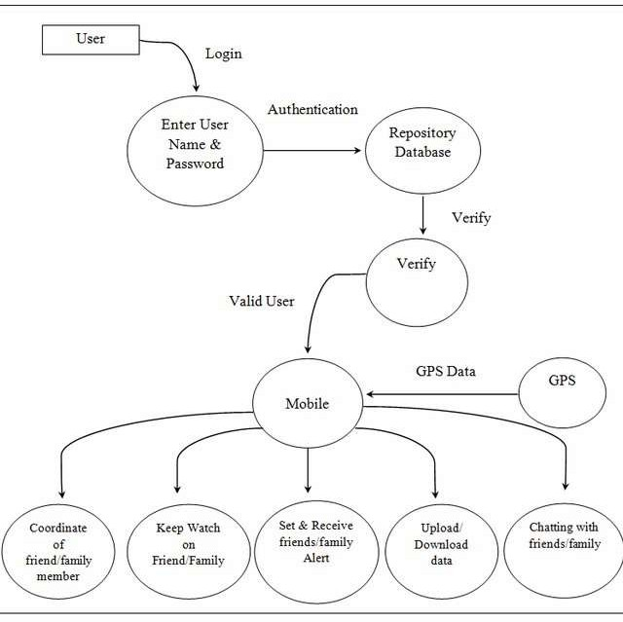

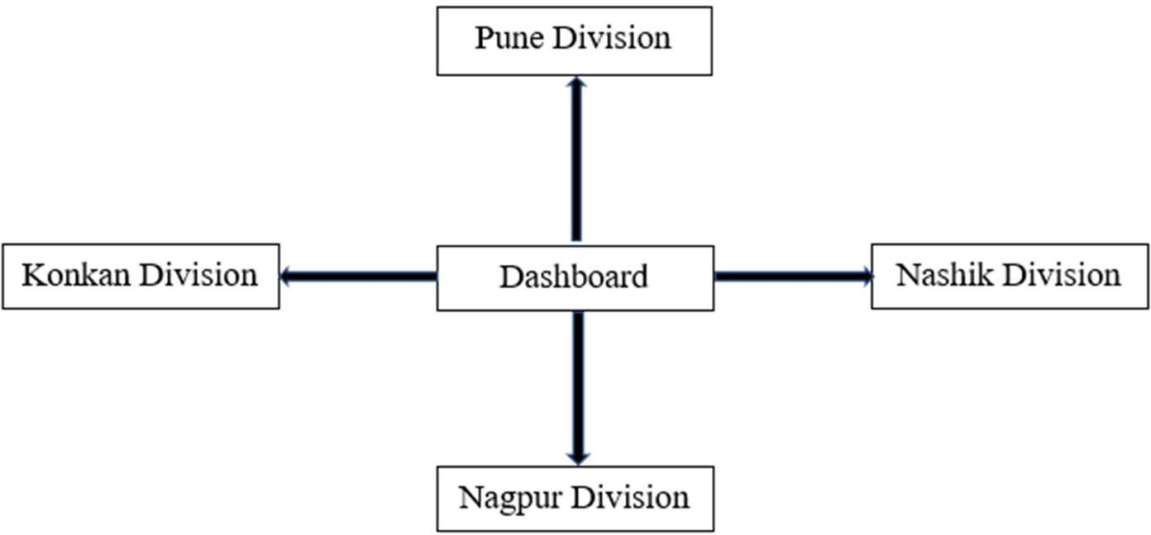

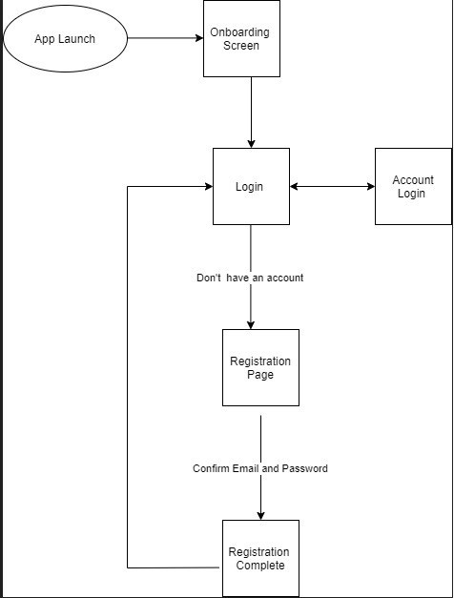

#### Fig 2. Proposed Model of Tourism Android Application

We will use the agile methodology, Object-Oriented Programming model and MVP (Model View Presenter) and MVC (Model View Presenter) are architectural patterns in our project. Agile Methodology is the term that is used for accrual and iterative app development approach that involves breaking down of the whole mobile app development process cycle in several different tasks. The method helps multiple teams with developing the different parts of the app simultaneously.

### DATA DESCRIPTION:

**Information -** We have used external Information for storing the Data. Our project did require an external database.

### DATA OBJECTS AND RELATIONSHIPS:

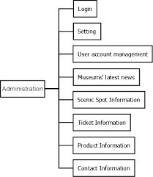

#### Fig 2. Data Flow Diagram

A data flow diagram (DFD) maps out the flow of information for any process or system. They can be used to analyze an existing system or model a new one. Like all the best diagrams and charts, a DFD can often visually “say” things that would be hard to explain in words, and they work for both technical and nontechnical audiences, from developer to CEO.

The above diagram shows parts, one is user and other is system part. It that authorized user can login and can give commands as well as data. The system will recognize and will execute the commands and will return the results to the user.

### DATA FLOW DIAGRAM:

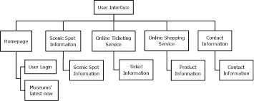

#### Fig 3. Level 0 DFD

The user logins to the application and user interface appears; the user is recognized by the application. Then it will check whether it is the authorized user, then action is performed as per the command given by the user.

Input is given by user by login into the application. Application will send the OTP to the user and after verifying the OTP it will further proceed to the Application.

### FLOW CHART:

Flow chart is the graphical representation of algorithms. Different symbols are used to represent flow chart. As the application is started, it first authenticates the authorized user, then you can surf the application and explore various parts of Maharashtra virtually as well as physically.

User gives the command, and it shows the information based on the searched place. The output is sent to user interface of the user which is in the readable format. And further it processes for the desired task.

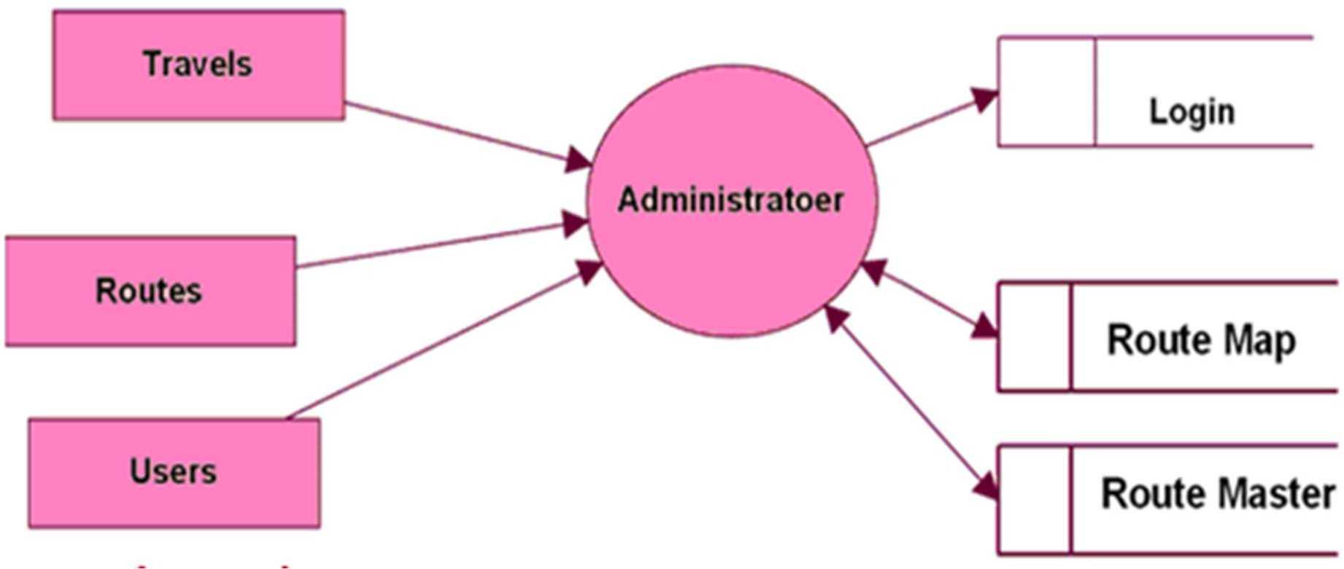

#### Fig 5. Flow Chart

* 1. 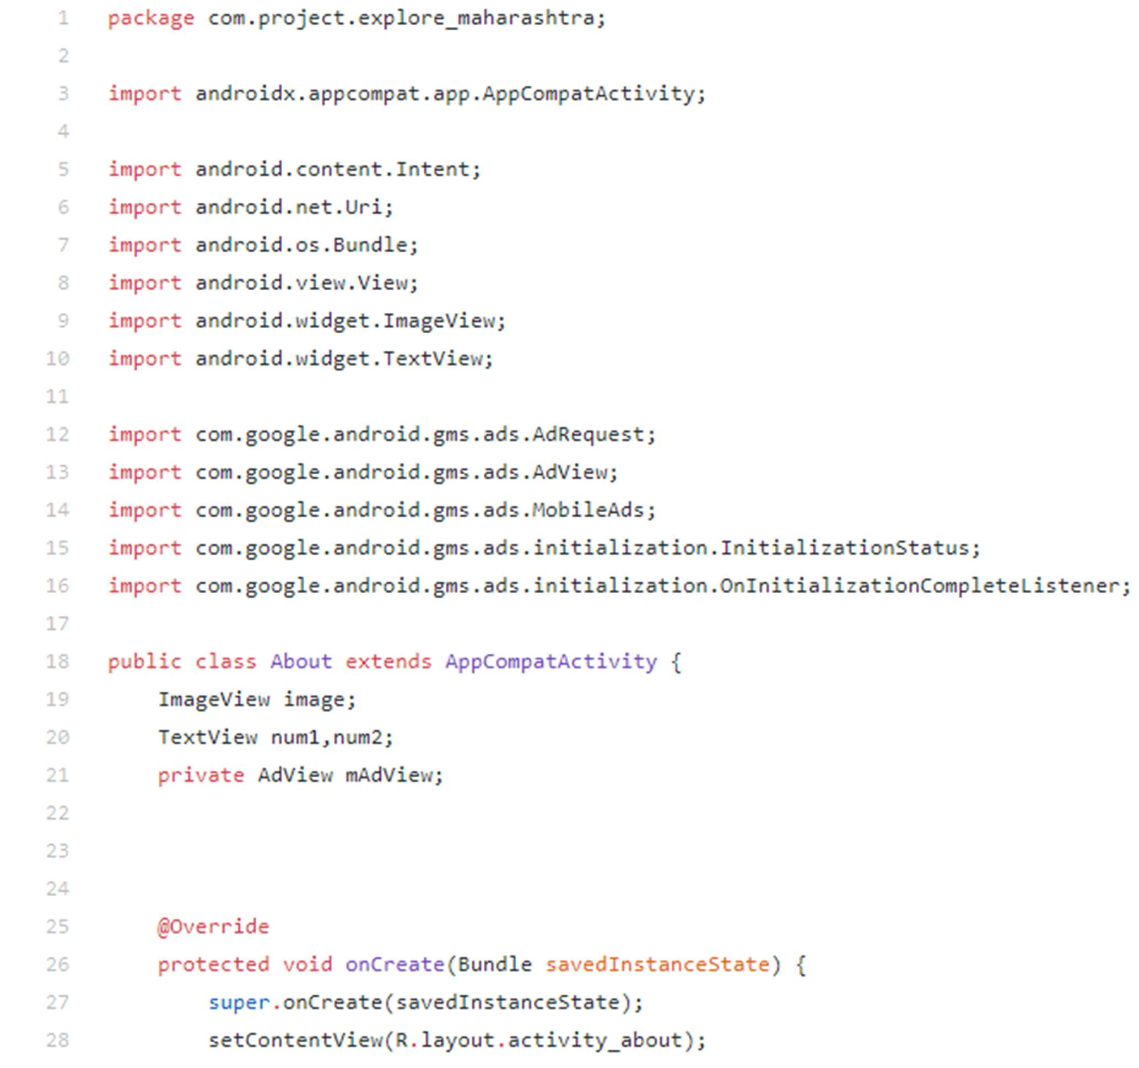**Code of Python:**

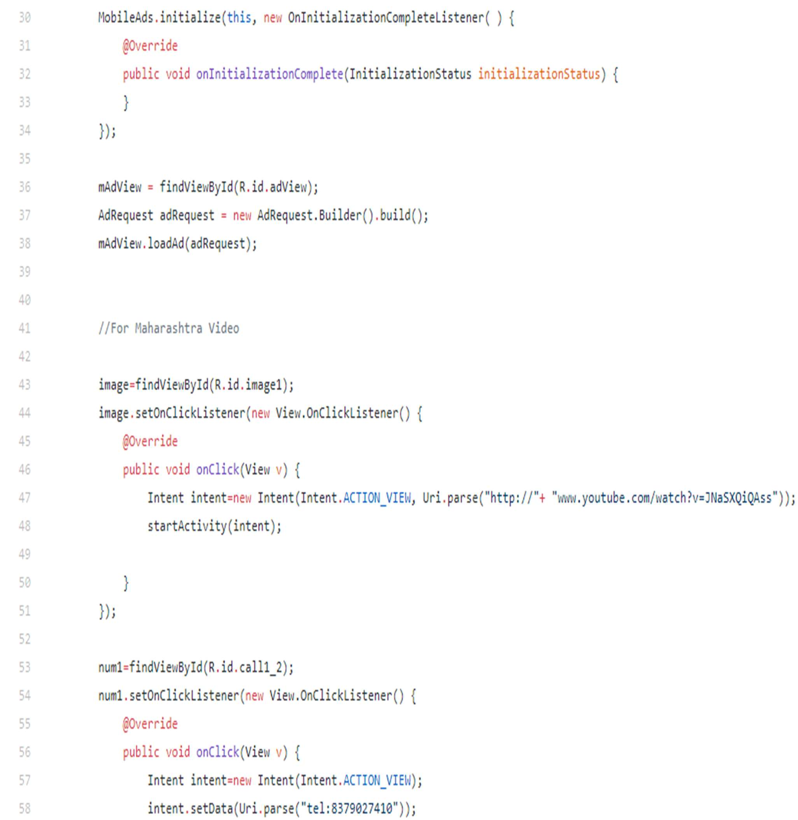

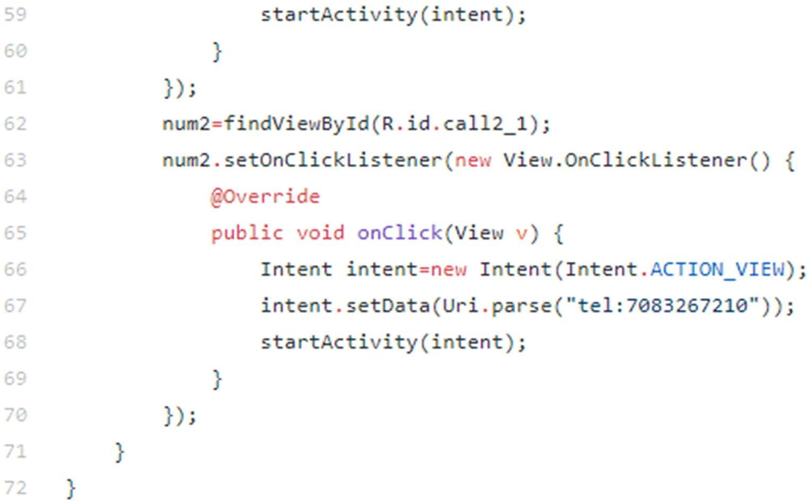

* 1. **XML Code:**

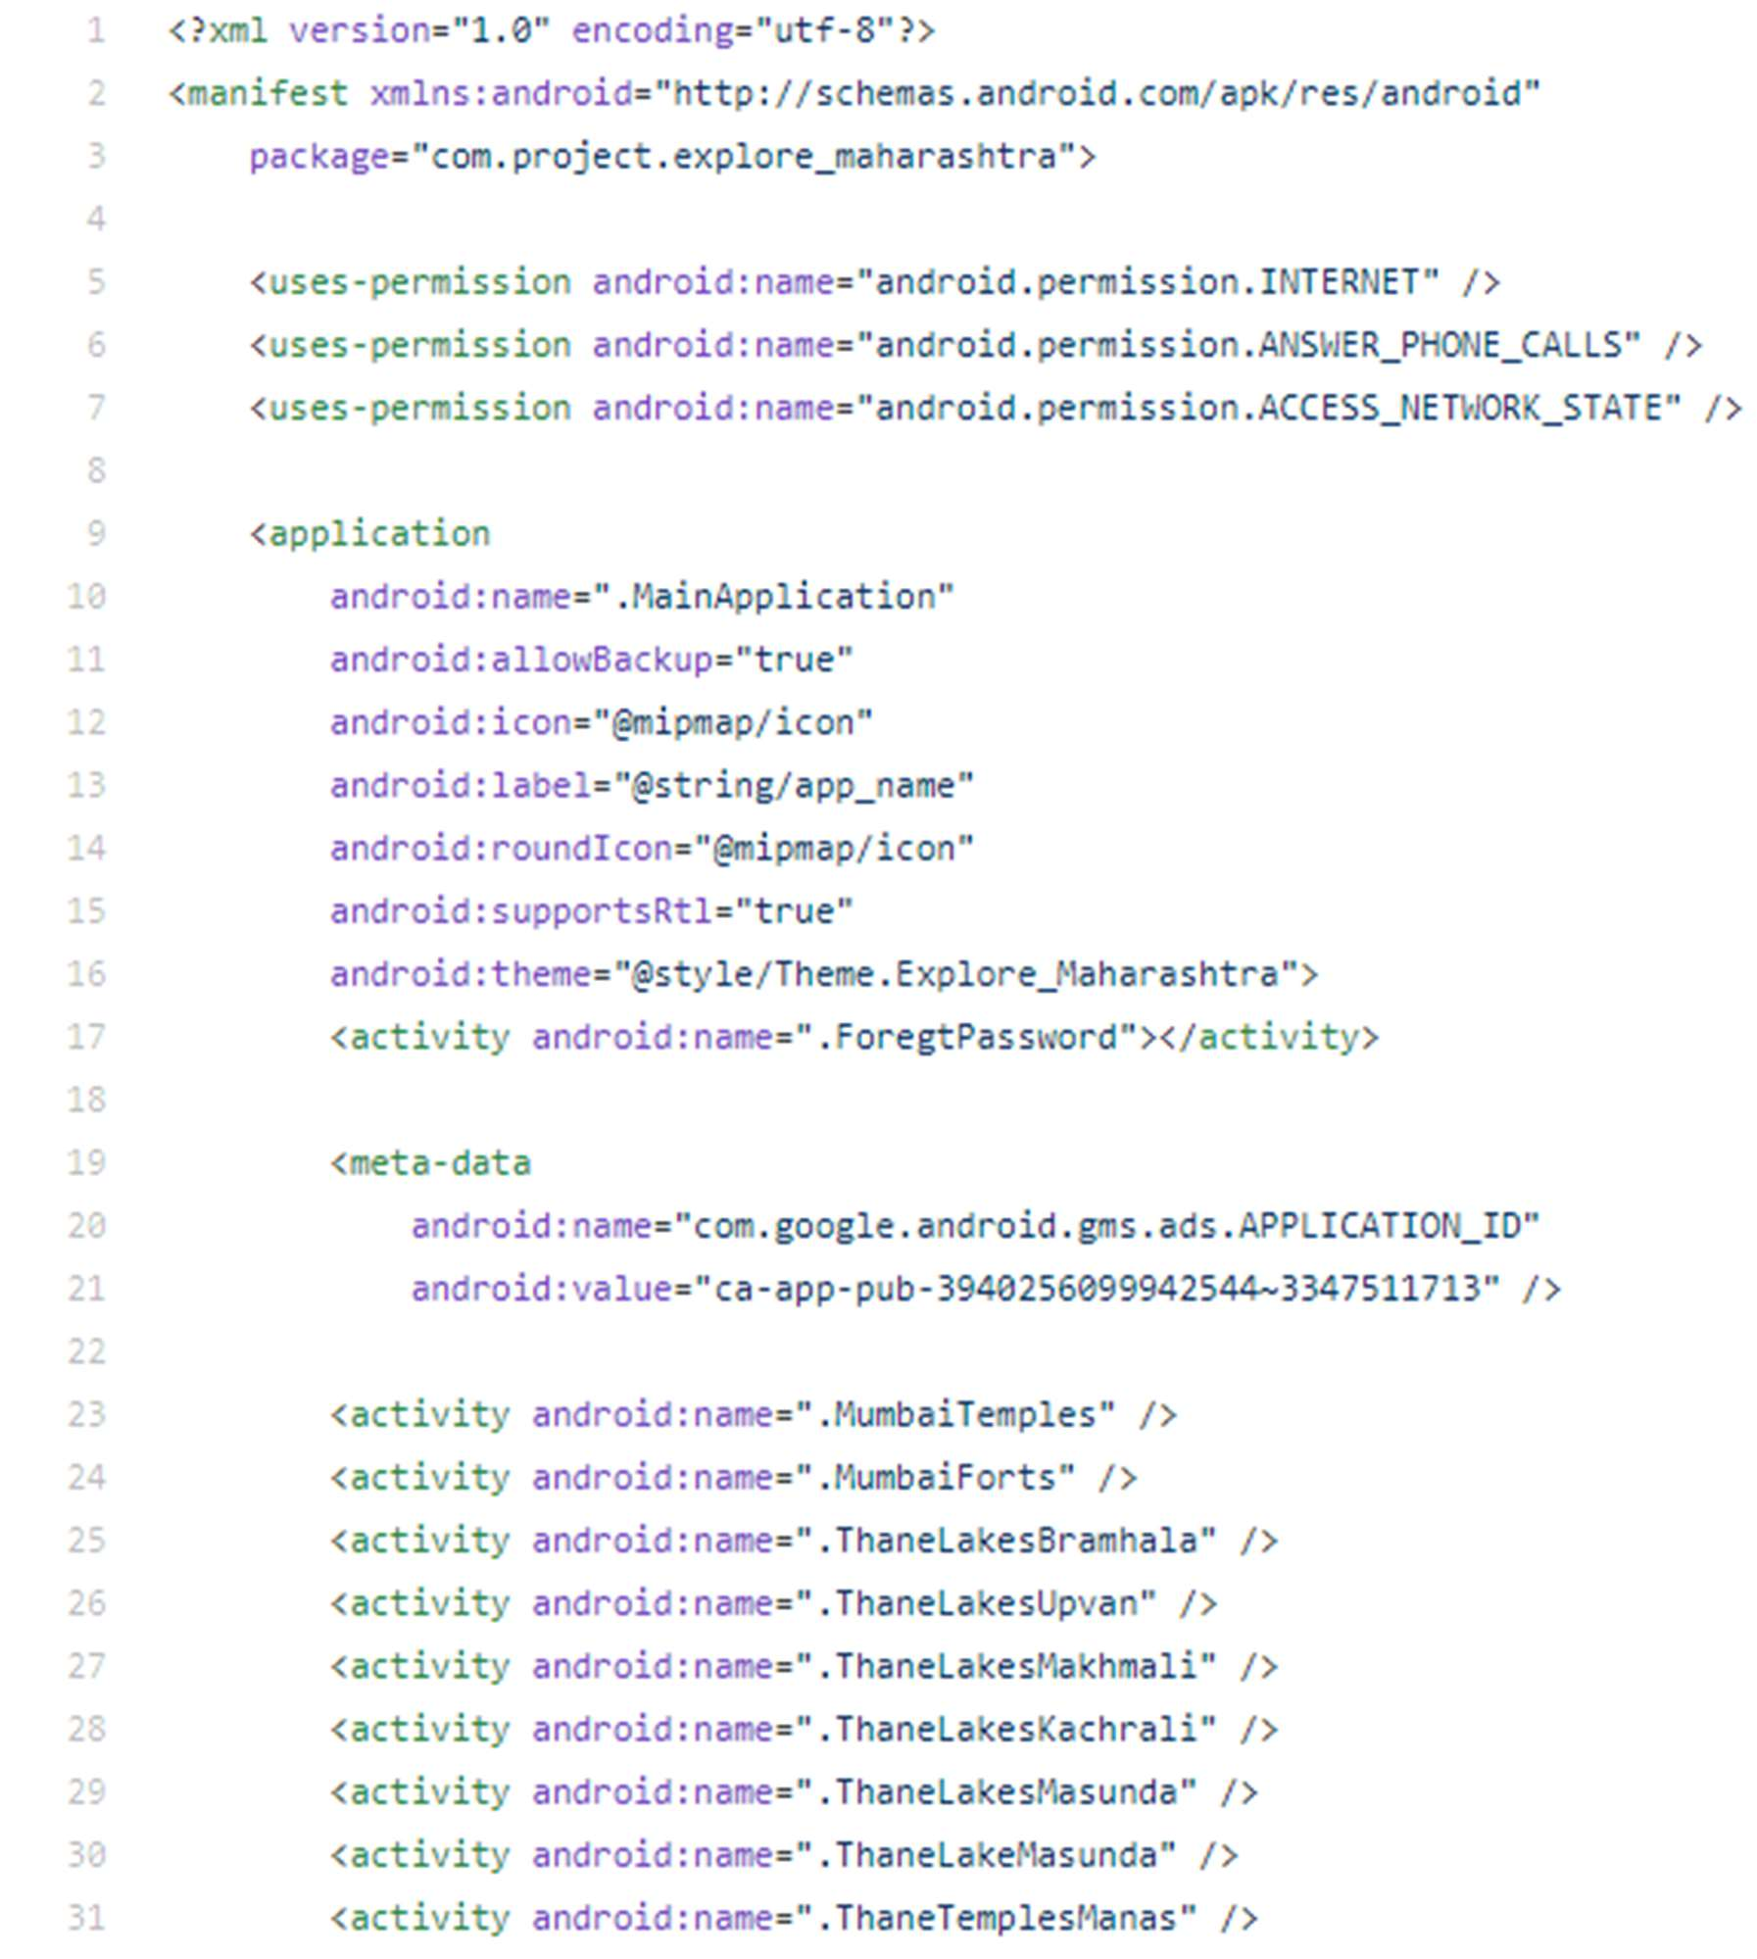

* 1. **SOFTWARE IMPLEMENTATION:**

**Java**

**Java** is a high-level, class-based, object-oriented programming language that is designed to have as few implementation dependencies as possible. It is a general-purpose programming language intended to let application developers write once, run anywhere (WORA), meaning that compiled Java code can run on all platforms that support Java without the need for recompilation. Java applications are typically compiled to bytecode that can run on any Java virtual machine (JVM) regardless of the underlying computer architecture.

The syntax of Java is similar to C and C++, but has fewer low-level facilities than either of them. The Java runtime provides dynamic capabilities (such as reflection and runtime code modification) that are typically not available in traditional compiled languages. As of 2019,

Java was one of the most popular programming languages in use according

to GitHub, particularly for client-server web applications, with a reported 9 million developers.

**Kotlin**

Kotlin is a cross-platform, statically typed, general-purpose programming language with type inference. Kotlin is designed to interoperate fully with Java, and the JVM version of Kotlin's standard library depends on the Java Class Library, but type inference allows its syntax to be more concise.

**Functions**

#### Following are the operations performed on the input in the system: Neumorphism ():

Neumorphism, or soft UI, is a visual style that combines background colors, shapes, gradients, highlights, and shadows to ensure graphic intense buttons and switches It is worth noting that Neumorphism is

not a replacement for flat design style, but an addition to app user interface design

#### Enum ():

Enumeration (or Enum) is a user defined data type in C. It is mainly used to assign names to integral constants, the names make a program easy to read and maintain.

#### Search ():

This operation searches the local database for the response of the command extracted

by the previous operation.

#### Response ():

This operation gives the output that we see on the screen or through speech for the

given command.

**Features**

#### Following is the list of some implemented features,

1. Access specific information.
2. News alerts.
3. Weather Information.
4. Displays date and time.
5. Open applications.
6. Opens virtual experience.
7. Notifications.
8. Display positive thoughts on interface.
9. Search information on Google or Wikipedia.

# 4.0 RESULTS AND APPLICATION

### PHASE 4

**RESULTS AND APPLICATION**

In this project, the user first needs to start the program. After starting the program, personal assistant will be able to take input from user with help of voice command. Then user search information depends upon his/her personal quires. If that quire is understood by personal assistant, it will respond on that quire with proper search else personal assistant response to user with „tries once again‟. Through this the user can search any quires or information.it can help to user to indexing the personal data which was recently stored in system. This is much valuable and constructive than library and as communication is possible between the user and the assistant, the customer be acquainted with about the condition of the given search

**GUI of Tourism Application (Maharashtra):**

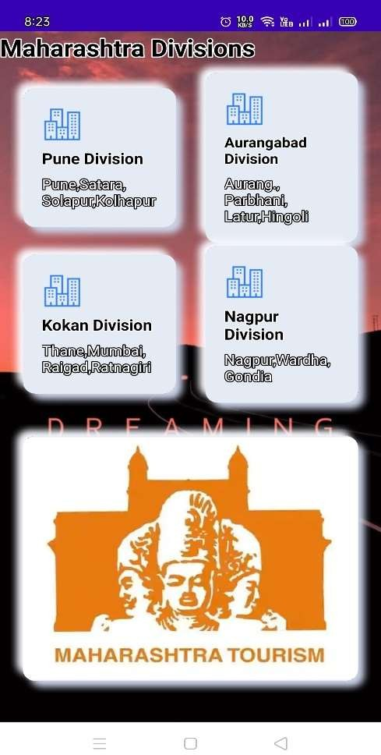

The above figure shows the Graphical User Interface (GUI) of our project named Development of Android Application for Maharashtra Tourism. It shows the current time and date. Also it shows the temperature, memory used, present location of user and some entertaining stuff.

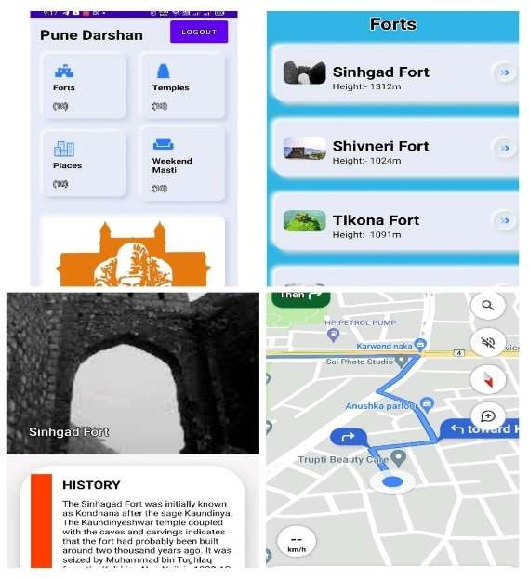

The Above figure explains the user interface done by using the term Neumorphism as we took four divisions. Every division has its separate page to follow for extra places in that particular division. Into it we can see the history about the place and learn something new by its given information. None other than that if you couldn’t find the destination you are searching for the Google Maps will help you out to reach the destination.

The Output of Android Application

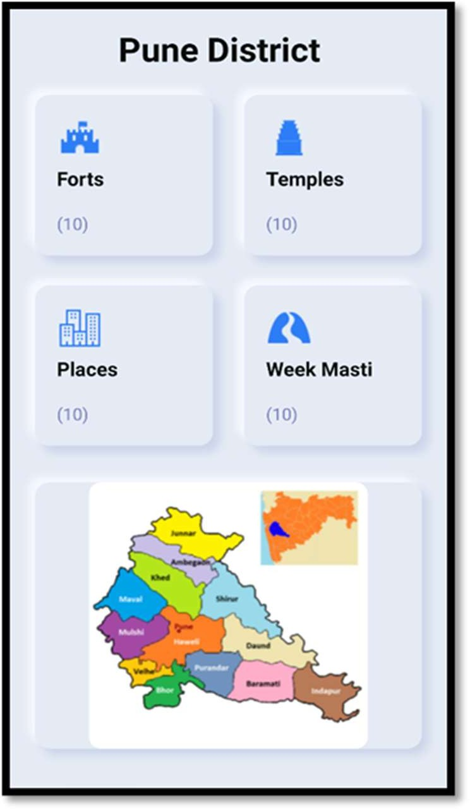

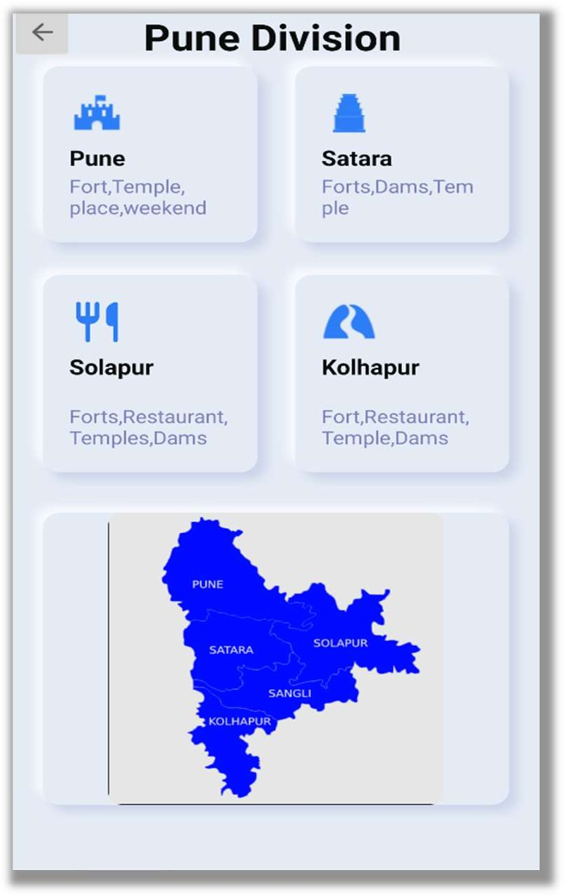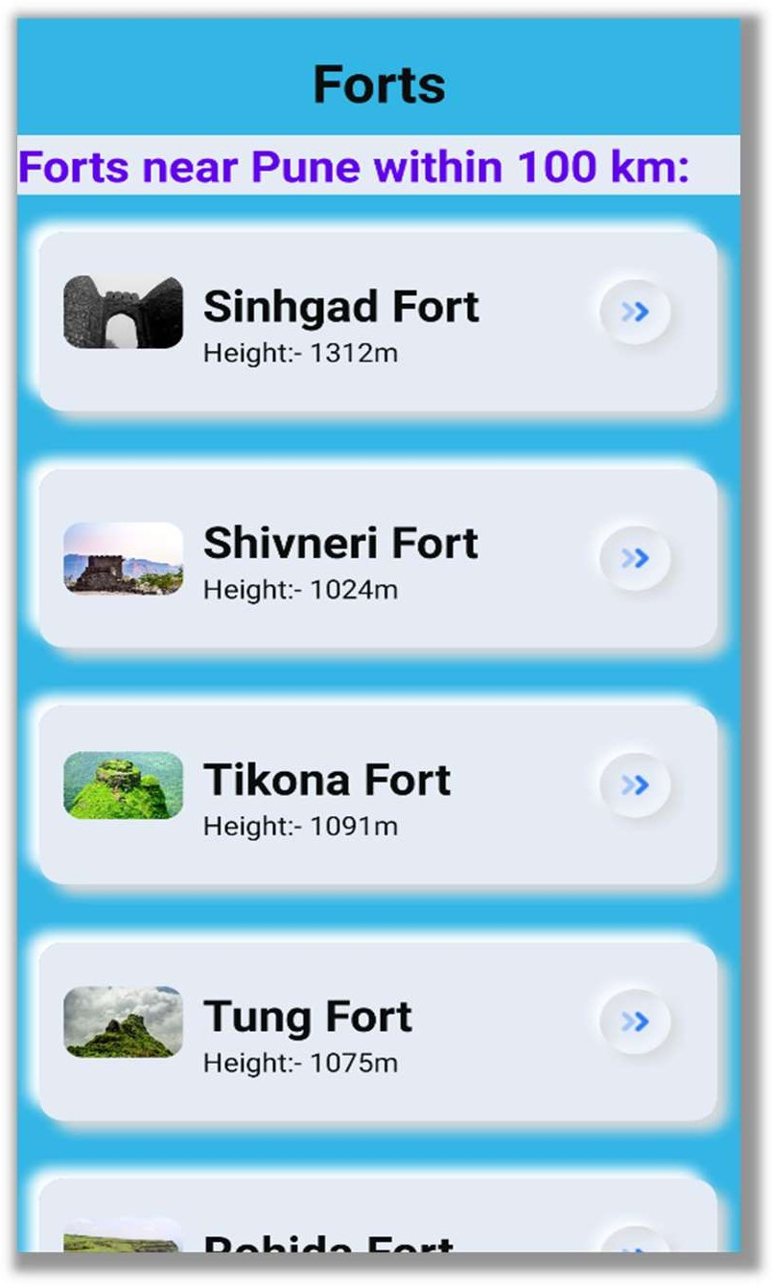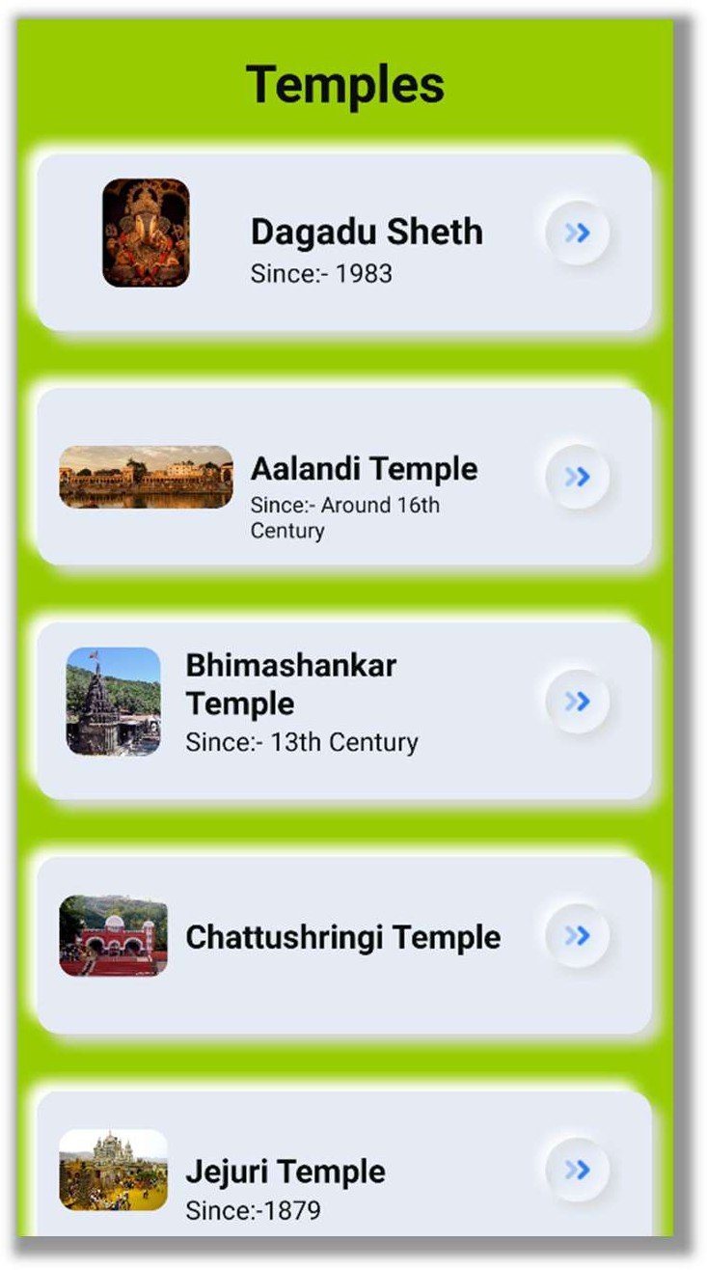

# 5.0 TESTING

## PHASE 5

**TESTING**

### SOFTWARE TESTING TYPES:

**PURPOSE OF TESTING**

The purpose of testing is to discover errors. Testing is the process of trying to discover every conceivable fault or weakness in a work product. It provides a way to check the functionality of components, sub-assemblies, assemblies and/or a finished product It is the process of exercising software with the intent of ensuring that the Software system meets its requirements and user expectations and does not fail in an unacceptable manner. There are various types of test. Each test type addresses a specific testing requirement.

### System Testing

System testing is a level of testing that validates the complete and fully integrated software product. The purpose of a system test is to evaluate the end-to-end system specifications. Usually, the software is only one element of a larger computer-based system.

### Unit Testing

Unit testing involves the design of test cases that validate that the internal program logic is functioning properly, and that program inputs produce valid outputs. All decision branches and internal code flow should be validated. It is the testing of individual software units of the application .it is done after the completion of an individual unit before integration. This is a structural testing, that relies on knowledge of its construction and is invasive. Unit tests perform basic tests at component level and test a specific business process, application, and/or system configuration. Unit tests ensure that each unique path of a business process performs accurately to the documented specifications and contains clearly defined inputs and expected results.

### Integration Testing

Integration tests are designed to test integrated software components to determine if they, actually run as one program. Testing is event driven and is more concerned with the basic outcome of screens or fields. Integration tests demonstrate that although the components were individually satisfaction, as shown by successfully unit testing, the combination of components is correct and consistent. Integration testing is specifically aimed at exposing the problems that arise from the combination of components.

### Functional Testing

Functional testing is a type of software testing that validates the software system against the functional requirements/specifications. The purpose of Functional tests is to test each function of the software application, by providing appropriate input, verifying the output against the Functional requirements.

### System Testing

System testing ensures that the entire integrated software system meets requirements. It tests a configuration to ensure known and predictable results. An example of system testing is the configuration oriented system integration test. System testing is based on process descriptions and flows, emphasizing pre-driven process links and integration points.

### White Box Testing

White Box Testing is a testing in which in which the software tester has knowledge of the inner workings, structure and language of the software, or at least its purpose. It is purpose. It is used to test areas that cannot be reached from a black box level.

### Black Box Testing

Black Box Testing is testing the software without any knowledge of the inner workings, structure or language of the module being tested. Black box tests, as most other kinds of tests, must be written from a definitive source document, such as specification or requirements document, such as specification or requirements document. It is a testing in which the software under test is treated, as a black box .you cannot “see” into it. The test provides inputs and responds to outputs without considering how the software works

### Unit Testing

Unit testing is usually conducted as part of a combined code and unit test phase of the software lifecycle, although it is not uncommon for coding and unit testing to be conducted as two distinct phases.

### GUI Testing

GUI means graphical user interface to test the friendliness of that system. Here we testing for the images, object properties, weather the screens are user under stable or not.

**Test Objectives**

* All field entries must work properly.
* Pages must be activated from the identified link.
* The entry screen, messages and responses must not be delayed.
* Features To Be Tested
* Verify that the entries are of the correct format
* No duplicate entries should be allowed
* All links should take the user to the correct page.

### INTEGRATION TESTING:

Software integration testing is the incremental integration testing of two or more integrated software components on a single platform to produce failures caused by interface defects. The task of the integration test is to check that components or software applications, e.g. components in a software system or – one step up – software applications at the company level – interact without error.

* + - * **Test Results:** All the test cases mentioned above passed successfully. No defects encountered.
      * **Test Results:** All the test cases mentioned above passed successfully. No defects encountered.
      * **Test Cases:** Set of inputs, execution conditions and expected results carried out for some objectives

### TEST CASE:

|  |  |  |  |  |  |
| --- | --- | --- | --- | --- | --- |
| **Sr.**  **No.** | **Test Objective** | **Input Data** | **Expected**  **Result** | **Actual**  **Result** | **Status** |
| 1 | Opening Program | Open the Program  manually | GUI should open  successfully | GUI open successfully | Pass |
| 2 | Password Authentication | Enter correct password | It should  accept the user | It accepts the user | Pass |
|  |  | Enter wrong password | It should not accept the  user | It does not accepts the  user | Pass |

#### Table 3: Test Cases for Login

**6.0 CONCLUSION**

**PHASE 6**

**CONCLUSION**

This research has meets and satisfied the requirements from the problems statements by enhancing the proposed system performances, provide adequate information for tourist, improve the usability aspect and finally the alert response system. Taken task like this in developing android application involves lots of obstacle and challenges due to rapid growth change technology. Considered of this project on travel guide Maharashtra, one can become an expert application developer that can stand on the market to earn money.

From the analysis of the result, we can conclude that our smart travel guide app is able to meet up the requirement for the traveler for a great traveling experience. As a conclusion, the design of the smart travel guide is able to perform as expected and can be further analyzed for future enhancement so that new features could be focused to produce a better solution by improving the effectiveness of the app. It enables free, secure, fast and easy usage. We can also conclude that the use of smart travel guide will definitely benefit the user by saving storage and time of the user which in turn makes this app user and practice friendly.

# 7.0 FUTURE SCOPE

## PHASE 7 FUTURE SCOPE

* + - 1. This project will be helpful for the travelers around the country and state with more added features in it. We will see a fragmented marketplace emerge. It will be a market where you are might into using default AI providers depending on the hardware purchase. This will lead to consumerfriction and third party solutions to remove incumbent solutions.
      2. Using this system as a framework, the system can be expanded to features security. Security is important these days so it can be combined with this system to give more advanced security features.
      3. In this, the voice authentication technology can be implemented for more security. More advancement are possible like operating on various tones or accents from different regions that mean it should be able to perform operations on various voice tones and accents..
      4. Further modifications are possible like learning the answer of questions that are not known by the voice assistant and replying whenever next time the same question is put up by the user.
      5. It will be time saving for the travelers to search around, so that they can visit their destination without any hesitation.
      6. Accuracy and Efficiency may not be up to mark in the Application but can be connected to Android Google Maps.

# 8.0 Publication

## PHASE 9

**Publication**

**Development of an Android Application for Maharashtra Guide Tourism**

**Development of an Android Application for Maharashtra Guide Tourism**

PROF. V.C.SANAP, TANMAY BIRARI, NIRMAL AVHAD, SIDRA KHAN, RAHUL NAGRAJAN

Lecturer, Dept. of Computer Engineering, AISSMS Polytechnic, Pune, Maharashtra, India Students, Dept. of Computer Engineering, AISSMS Polytechnic, Pune, Maharashtra, India

P DF  10.15680/IJIRSET.2021.1006186



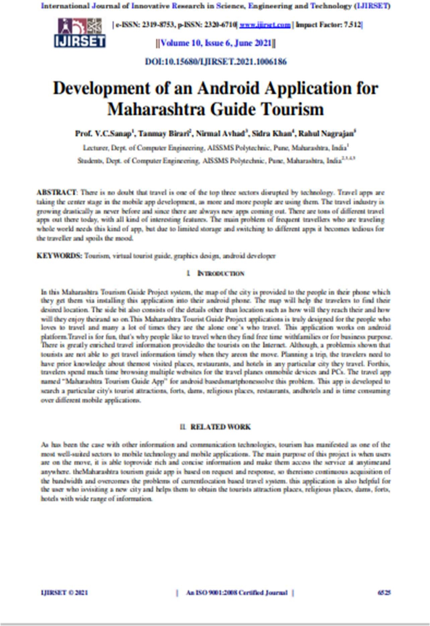

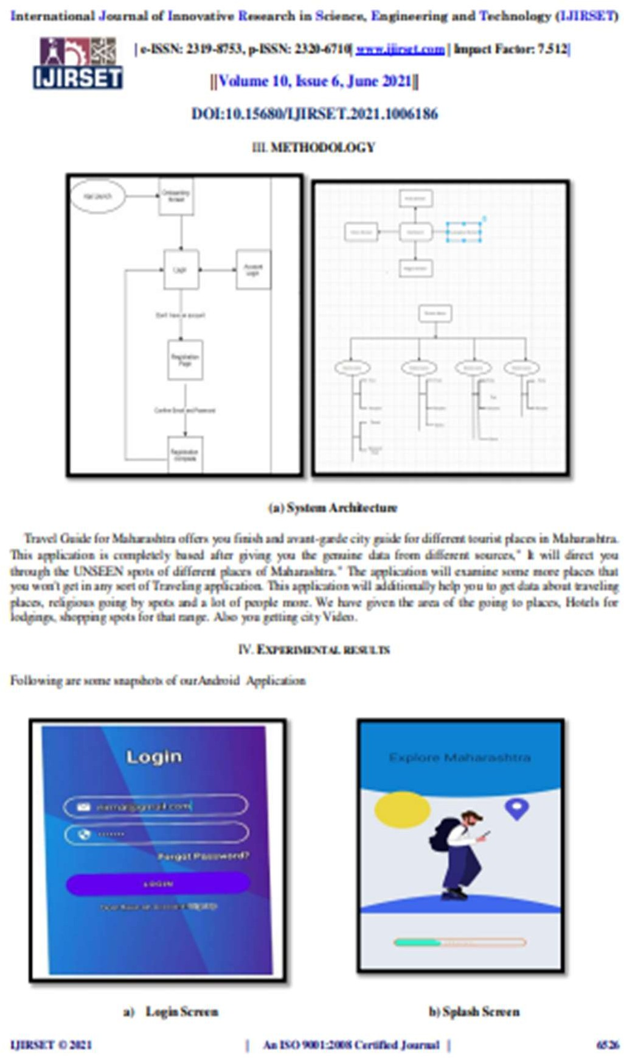

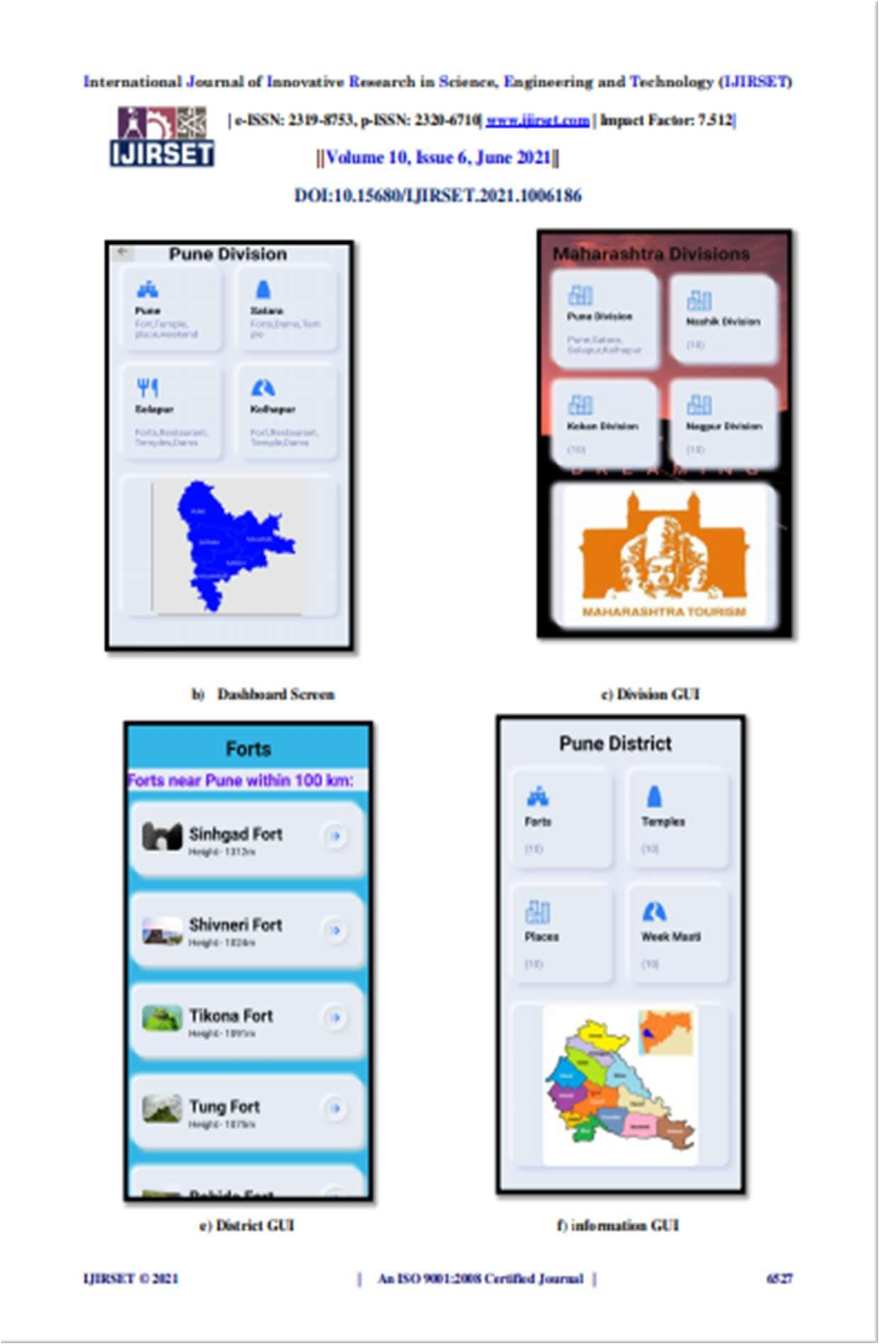

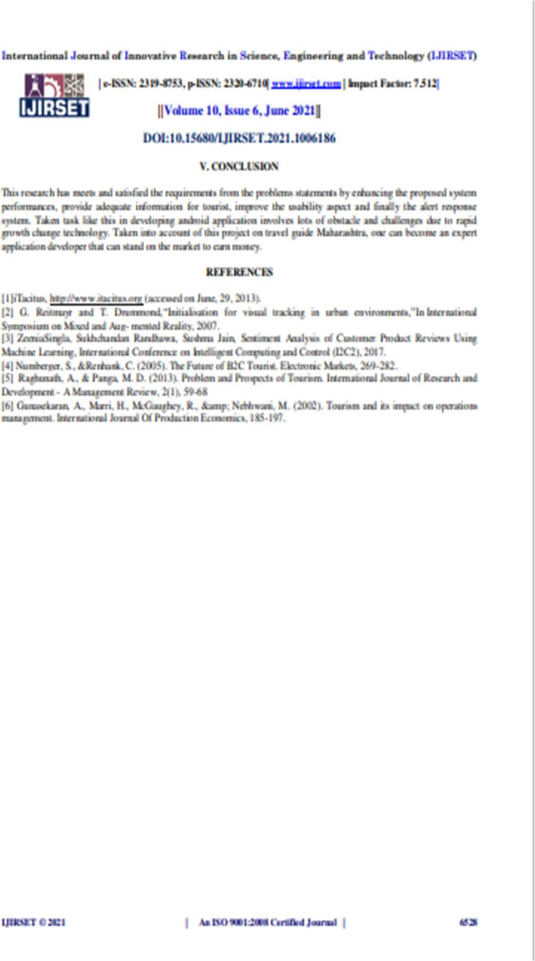



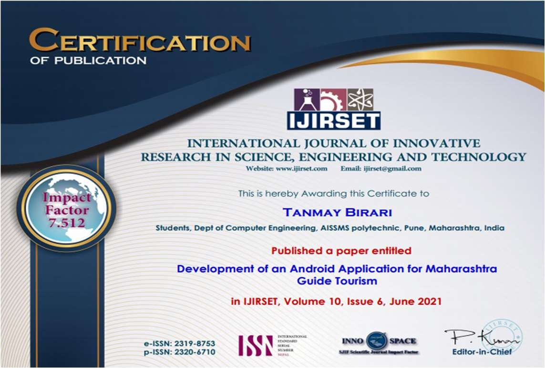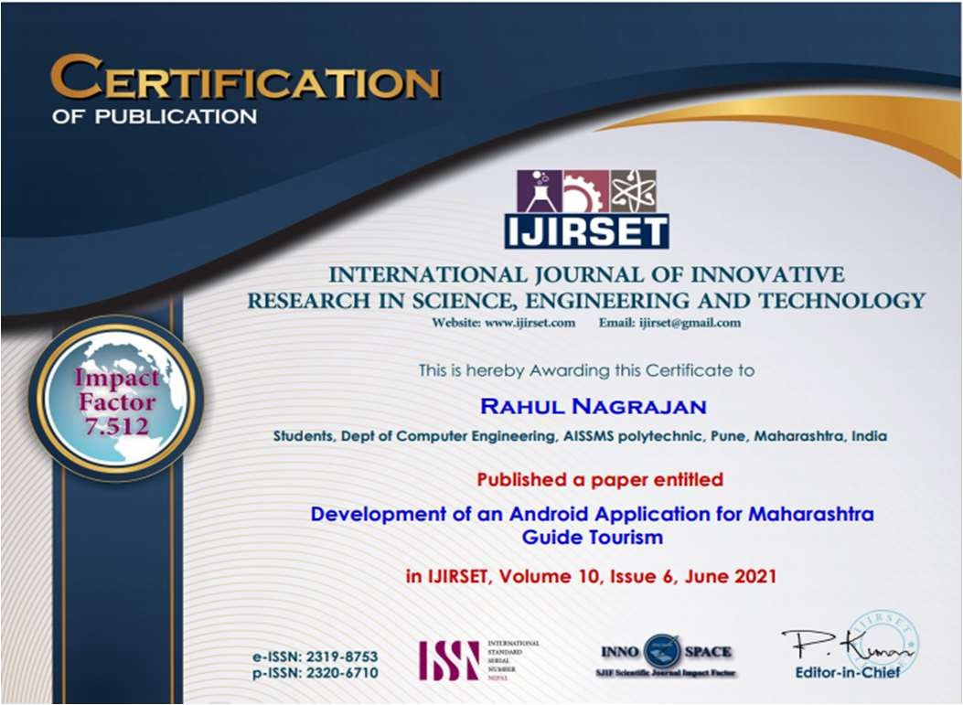**Certificates Provided By Paper Publications:**

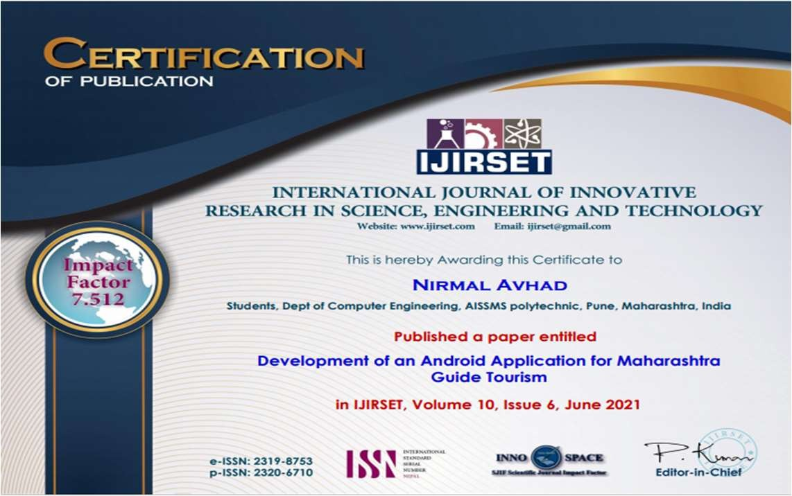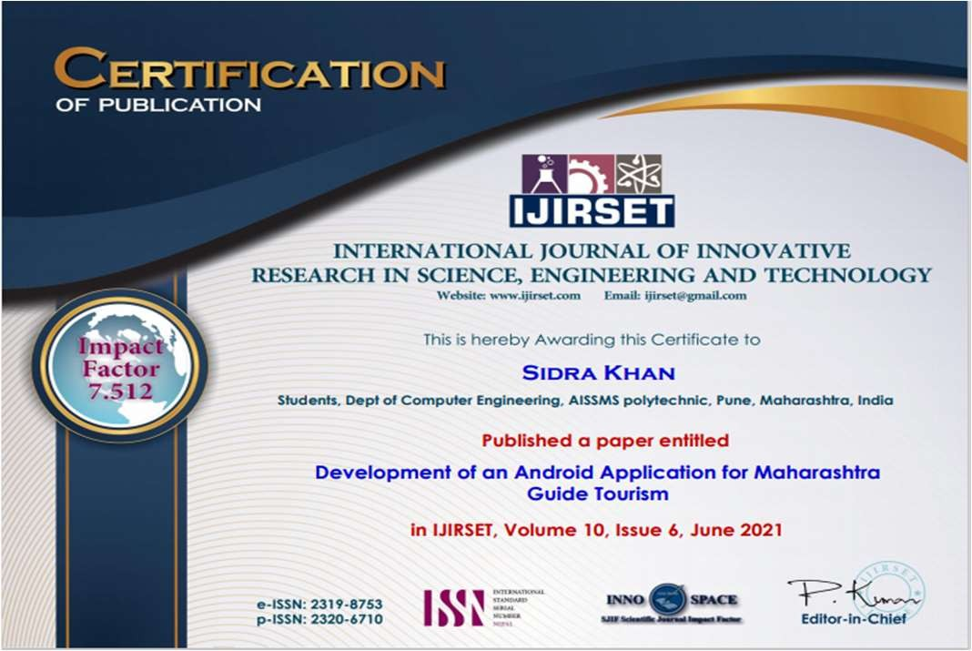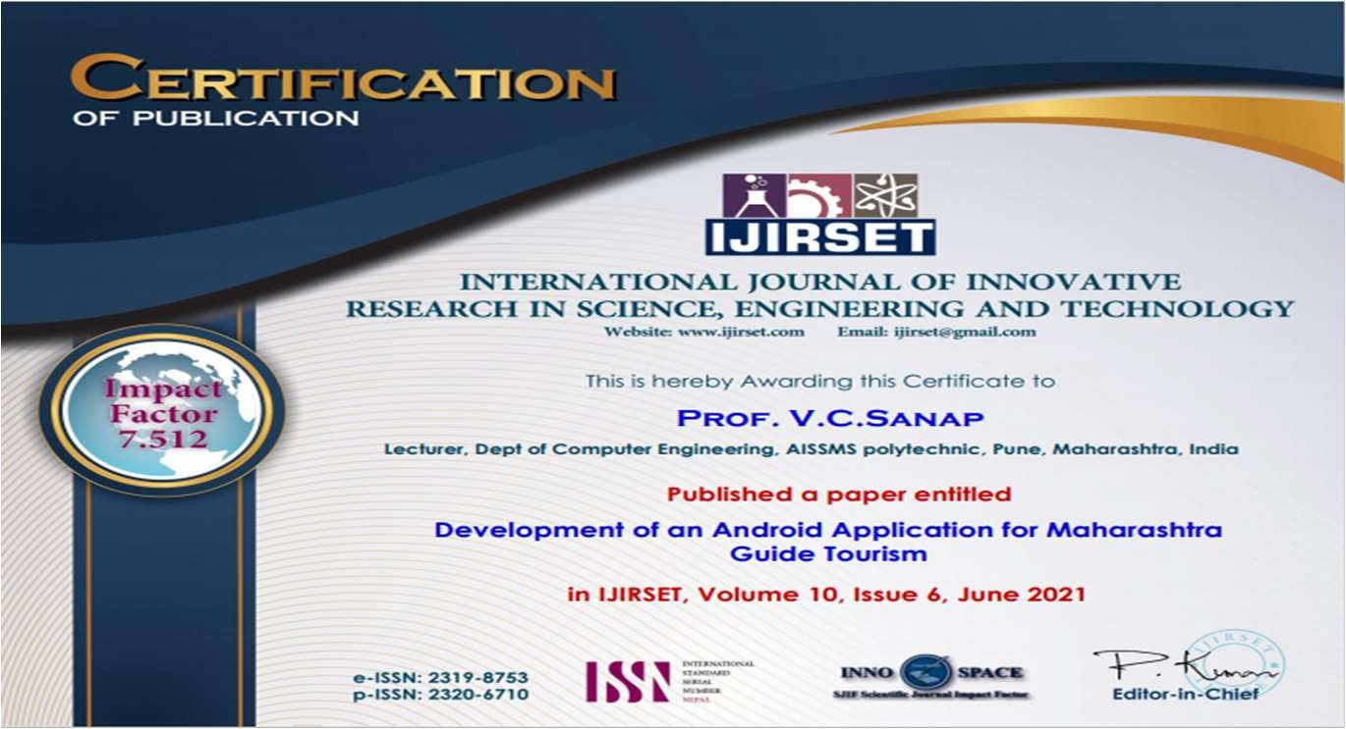

**9.0 REFERENCS & BIBLIOGRAPHY**

**PHASE 10 REFERENCES & BIBLIOGRAPHY**

* + - * 1. International Research Journal of Engineering and Technology (IRJET) e-ISSN: 2395 -0056 Volume: 03 Issue: 05 | May-2016 [www.irjet.net](http://www.irjet.net/) p-ISSN: 2395-0072
        2. iTacitus, [http://www.itacitus.org](http://www.itacitus.org/) (accessed on June, 29, 2013).
        3. G. Reitmayr and T. Drummond,“Initialisation for visual tracking in urban environments,”In International Symposium on Mixed and Aug- mented Reality, 2007.
        4. International Research Journal of Engineering and Technology (IRJET) e-ISSN: 2395-0056 Volume: 05 Issue: 04 | Apr-2018 [www.irjet.net](http://www.irjet.net/) p-ISSN: 2395-0072

© 2018, IRJET | Impact Factor value: 6.171 | ISO 9001:2008 Certified Journal | Page 2044 Virtual Tourism Shabnam Shaikh1, Karan Bokde2, Ameya Ingale3, Prof. Bhanu Tekwani4 1,2,3 Students, Vidyalankar Institute of Technology, Mumbai 4 Professor, Vidyalankar Institute of Technology, Mumbai

* + - * 1. Reality Technology Overview for Tourism App Development
        2. Raghunath, A., & Panga, M. D. (2013). Problem and Prospects of Tourism. International Journal of Research and Development - A Management Review, 2(1), 59-68
        3. Gunasekaran, A., Marri, H., McGaughey, R., &amp; Nebhwani, M. (2002).

Tourism and its impact

on operations management. International Journal Of Production Economics, 185-197